[Indian J Nucl Med](https://www.ncbi.nlm.nih.gov/pmc/articles/PMC3237228/). 2011 Apr-Jun; 26(2): 99–101.

doi:  [10.4103/0972-3919.90262](https://dx.doi.org/10.4103%2F0972-3919.90262)

PMCID: PMC3237228

PMID: [22174517](https://www.ncbi.nlm.nih.gov/pubmed/22174517)

PET/CT in the evaluation of anti-NMDA-receptor encephalitis: What we need to know as a NM physician

[S Padma](https://www.ncbi.nlm.nih.gov/pubmed/?term=Padma%20S%5BAuthor%5D&cauthor=true&cauthor_uid=22174517), [P Shanmuga Sundaram](https://www.ncbi.nlm.nih.gov/pubmed/?term=Sundaram%20PS%5BAuthor%5D&cauthor=true&cauthor_uid=22174517), and [Bobby Varkey Marmattom](https://www.ncbi.nlm.nih.gov/pubmed/?term=Marmattom%20BV%5BAuthor%5D&cauthor=true&cauthor_uid=22174517)1

[Author information ►](https://www.ncbi.nlm.nih.gov/pmc/articles/PMC3237228/) [Copyright and License information ►](https://www.ncbi.nlm.nih.gov/pmc/articles/PMC3237228/) [Disclaimer](https://www.ncbi.nlm.nih.gov/pmc/about/disclaimer/)

[Go to:](https://www.ncbi.nlm.nih.gov/pmc/articles/PMC3237228/)

Abstract

Anti *N*-methyl-d-aspartate receptor encephalitis (ANMDARE), also known as limbic encephalitis (LE), is a treatable rare disorder characterized by personality changes, irritability, depression, seizures, memory loss and sometimes dementia. It is classified under paraneoplastic syndrome (PNS) and produces antibodies against NR1 and NR2 subunits of glutamate aspartate receptor. It is thought to be closely related with malignancies like small cell lung cancer, ovarian teratoma and Hodgkin's lymphoma, apart from testis, breast and rarely gastric malignancies. Non-paraneoplastic encephalitis cases are the ones with no detectable malignancy and may be triggered by severe infection. As nuclear medicine physicians, we must be aware of the diverse presentation of ANMDARE or LE and should include a whole body positron emission tomography / computed tomography (PET/CT) and not just brain PETCT during imaging. We describe the first case of PET/CT in an idiopathic ANMDARE Indian adolescent girl.

**Keywords:**Anti NMDR encephalitis, Hodgkin's lymphoma, limbic encephalitis, ovarian teratoma, whole body PET/CT

INTRODUCTION

Anti *N*-methyl-d-aspartate receptor encephalitis (ANMDARE), also known as limbic encephalitis, is a rare disorder characterized by quintet of psychiatric manifestations like seizures, unresponsiveness, dysautonomia and movement disorders.[[1](https://www.ncbi.nlm.nih.gov/pmc/articles/PMC3237228/" \l "ref1)] It is of clinical interest as it is a paraneoplastic debilitating syndrome, which is curable when the underlying malignancy is removed. Neurological symptoms preceded the cancer diagnosis in 60% of patients.[[2](https://www.ncbi.nlm.nih.gov/pmc/articles/PMC3237228/" \l "ref2)] Most of the times, a combination of symptoms, magnetic resonance imaging (MRI) findings and paraneoplastic antibodies establish the diagnosis of paraneoplastic syndrome (PNS). Gultekin *et al*. showed that 57% of their patients had abnormal MRI.[[3](https://www.ncbi.nlm.nih.gov/pmc/articles/PMC3237228/" \l "ref3)] Antineuronal antibodies were positive in CSF or serum in 60% of patients.[[1](https://www.ncbi.nlm.nih.gov/pmc/articles/PMC3237228/" \l "ref1),[2](https://www.ncbi.nlm.nih.gov/pmc/articles/PMC3237228/" \l "ref2)] However, antibody negative cases have better neurological outcome.

CASE REPORT

Our patient, a 13-year-old girl, presented initially with acute behavioral changes and rapid deterioration in academic performance. Electroencephalogram (EEG) and a contrast MRI brain were normal. Two days prior to hospitalization, she developed bruxism and seizures. On examination, the patient was drowsy, unresponsive, and her eyes opened to painful stimuli. Light reflex was present with roving eye movements. The patient was treated with phenargan, haloperidol, put on intubation and mechanical ventilation due to oxygen desaturation. Lumbar puncture revealed clear fluid with a total count of 32 cells, all lymphocytes, 52 mg% of protein and normal sugar. CSF evaluations for encephalitis were negative [herpes simplex virus (HSV) 1/II, cytomegalovirus (CMV), varicella zoster virus (VZV), measles, mumps, rubella, enterovirus, *Mycobacterium tuberculosis*, Cryptococcus, *Toxoplasma gondii* and *Streptococcus pneumoniae*]. Arterial ammonia levels were normal, however, urine ketones were positive. Tandem mass spectroscopy for inborn errors of metabolism was negative. Fatty acid oxidation defects, organic acid disorders, amino acid disorders and urea cycle disorders were excluded. Nevertheless, she was put on a low-protein diet. Twenty days after admission, she developed oro-facial grimacing movement (like chewing, vacant smiling, bruxism and facial twitching) with oculogyric deviation and twisting choreic movements of the left leg. Another contrast-enhanced MRI of the brain was reported as normal. Multiple repeat EEG showed no evidence of epileptiform activity. The patient continued to have episodic hyperventilation, tachy/brady arrhythmias and blood pressure variations. Clinically ANMDARE was suspected and antineuronal antibodies were found to be positive. Due to her overall poor general condition, an ictal and interictal study was not performed, but she was referred to us for Fluorine-18 fluorodeoxyglucose Positron emission tomography - Computed tomography (18F FDG PET/CT) imaging. Both brain and whole body images up to mid thigh were acquired using an 8-slice PET/CT camera in euglycemic, ictal free status. Patient was under continuous EEG monitoring, especially at the time of FDG injection, to rule out an ictal or peri ictal phase. Images showed hypometabolism in left temporal and occipital cortex [[Figure 1](https://www.ncbi.nlm.nih.gov/pmc/articles/PMC3237228/figure/F1/)]. Diffuse FDG uptake was noted in bilateral lungs with consolidation in bilateral upper, lower lobes apical, posterior segments, and diffuse ground-glass opacities were also noted in CT images. Findings were attributed to aspiration pneumonitis [[Figure 2](https://www.ncbi.nlm.nih.gov/pmc/articles/PMC3237228/figure/F2/)]. PET images also showed moderate diffuse FDG uptake in bone marrow (seen in MIP image) and spleen (no splenomegaly) [[Figure 3](https://www.ncbi.nlm.nih.gov/pmc/articles/PMC3237228/figure/F3/)]. Associated minimally FDG avid multiple supra and infradiaphragmatic lymph nodes were reported (i.e. standard uptake value SUV between 2.5 and 4 g/ml in bilateral level 2, right upper paratracheal, subcarinal, right axillary, left para-aortic, left external iliac and right external iliac lymph nodes) which were given importance in this clinical setting to rule out a lymphoproliferative disorder, but with no evidence of a teratoma. However, USG-guided cervical node biopsies ruled out lymphoma and suggested reactive lymphadenitis. Bone marrow aspiration biopsy also showed reactive changes. Thus, a non-paraneoplastic type of ANMDARE with no detectable malignancy was suspected. Thus, in such cases a whole body PET/CT is warranted to confirm or rule out teratoma or other possible malignancies apart from confirming the cerebral involvement.[[4](https://www.ncbi.nlm.nih.gov/pmc/articles/PMC3237228/" \l "ref4)] Treatment of choice is usually removal of the underlying neoplasm, combined with immunotherapy (plasma exchange, IV immunoglobulin, steroids). Our patient was finally considered to be a case of idiopathic ANMDARE and she was treated with only IV steroids due to financial constraints. At the last follow-up, she was minimally conscious.

[[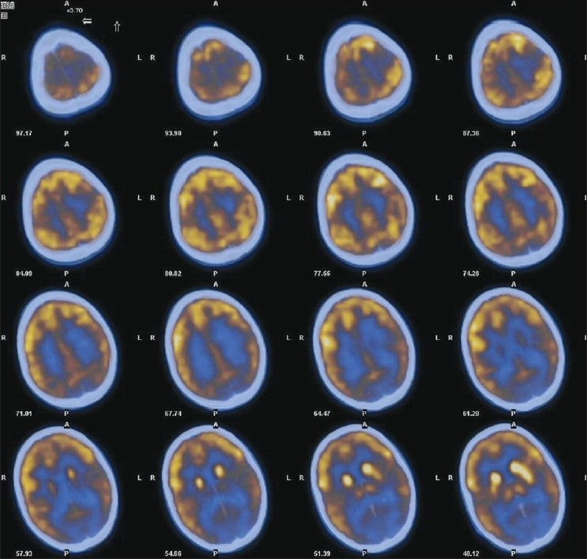](https://www.ncbi.nlm.nih.gov/pmc/articles/PMC3237228/figure/F1/)](https://www.ncbi.nlm.nih.gov/pmc/articles/PMC3237228/figure/F1/)

[Figure 1](https://www.ncbi.nlm.nih.gov/pmc/articles/PMC3237228/figure/F1/)

FDG PET/CT brain transaxial images showing hypometabolism in left temporal and occipital cortex

[[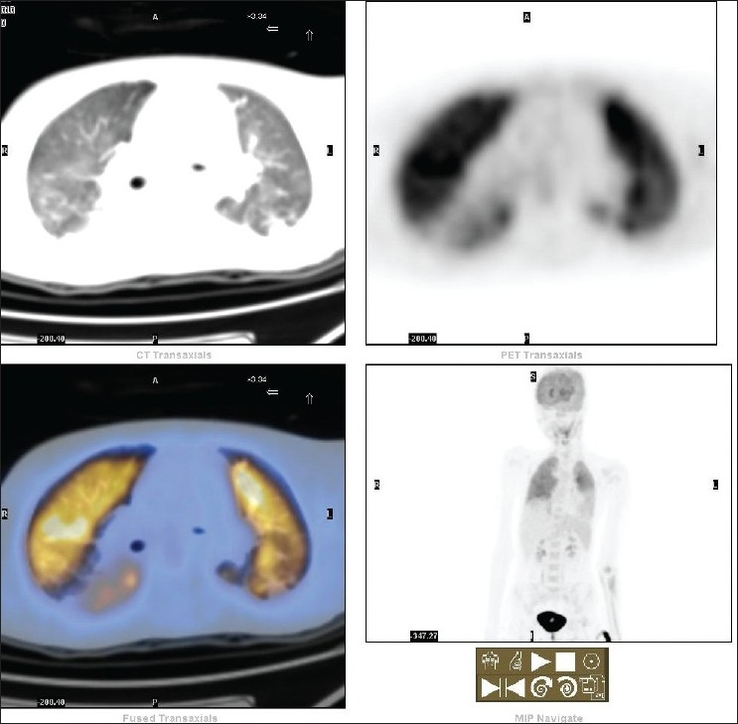](https://www.ncbi.nlm.nih.gov/pmc/articles/PMC3237228/figure/F2/)](https://www.ncbi.nlm.nih.gov/pmc/articles/PMC3237228/figure/F2/)

[Figure 2](https://www.ncbi.nlm.nih.gov/pmc/articles/PMC3237228/figure/F2/)

18F FDG PET/CT images of thorax show diffuse FDG avid bilateral lungs with consolidation in bilateral upper, lower lobes apical, posterior segments and diffuse ground-glass opacities. Findings were attributed to aspiration pneumonitis

[[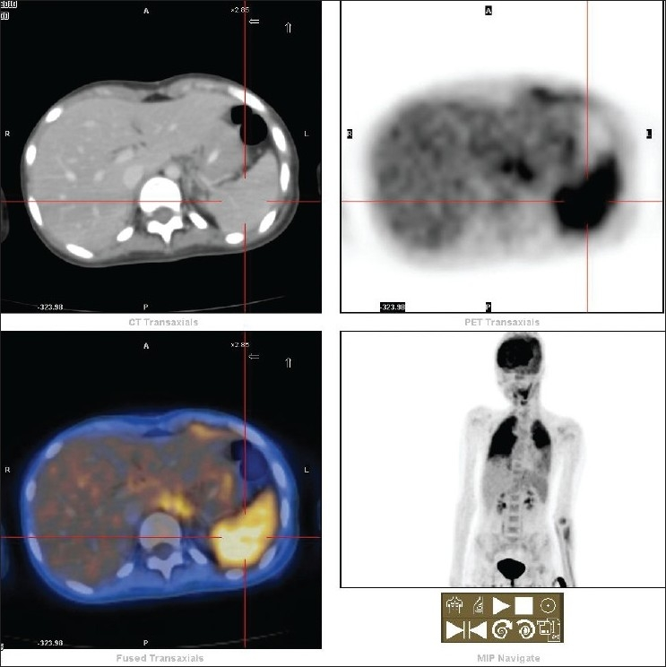](https://www.ncbi.nlm.nih.gov/pmc/articles/PMC3237228/figure/F3/)](https://www.ncbi.nlm.nih.gov/pmc/articles/PMC3237228/figure/F3/)

[Figure 3](https://www.ncbi.nlm.nih.gov/pmc/articles/PMC3237228/figure/F3/)

PET/CT transaxial images of abdomen show moderate diffuse FDG uptake in bone marrow (in MIP image) and spleen (no splenomegaly) with associated minimally FDG avid multiple supra and infradiaphragmatic lymph nodes present (i.e. SUV between 2.5 and 4 g/ml in bilateral level 2, right upper paratracheal, subcarinal, right axillary, left para-aortic, left external iliac and right external iliac lymph nodes), raising the possibility of a lymphoproliferative disorder, but no evidence of a teratoma. However, USG-guided cervical node biopsies ruled out lymphoma and suggested reactive lymphadenitis. Bone marrow aspiration biopsy also showed reactive changes. Response to treatment is poor. Our patient was treated with only IV steroids due to financial constraints. At the last follow-up, she was minimally conscious

[Go to:](https://www.ncbi.nlm.nih.gov/pmc/articles/PMC3237228/)

DISCUSSION

PNS is a disabling but rare disease caused by autoimmune processes triggered by cancer and directed against antigens common to both the cancer and nervous system.[[3](https://www.ncbi.nlm.nih.gov/pmc/articles/PMC3237228/" \l "ref3)]

*N*-methyl-d-aspartate-selective glutamate receptor (NR), predominantly involved in synaptic plasticity and memory function, gets deranged in this form of encephalitis. It produces antibodies against NR1 and NR2 subunits of glutamate receptor. These antibodies bind to the NR2B and, to a lesser extent, the NR2A subunits of NMDAR. NR2B binds to glutamate and is avidly expressed in the hippocampal and forebrain neurons of human beings.[[5](https://www.ncbi.nlm.nih.gov/pmc/articles/PMC3237228/" \l "ref5)] There is a reduction in gamma-aminobutyric acid (GABA) release, leading to disinhibition of postsynaptic glutamatergic transmission and secondarily excessive release of glutamate in the prefrontal/subcortical structures, and glutamate and dopamine dysregulation.

The typical clinical picture is seen in young women that translates through five phases. The initial prodromal phase, manifests like a viral flu. In the 2nd phase, patients present with acute psychosis and behavioral symptoms. In the 3rd phase, patients develop intractable seizures, are often unresponsive and require multiple anticonvulsants and often mechanical ventilation. In the 4th phase, patients develop hyperkinetic episodes with oro-facial grimacing. The 5th phase is the gradual recovery which can last 3 years or more. Other peculiar features of this autoimmune encephalitis are central hypoventilation and dysautonomia with severe oro-facial dyskinesias. Brain PET findings can be variable depending on the course and timing of the scan.[[6](https://www.ncbi.nlm.nih.gov/pmc/articles/PMC3237228/" \l "ref6)] Patients in acute phase of illness can have cerebral hypermetabolism, while relapsing cases have demonstrated reduced FDG uptake in the cerebral cortex, with the temporal regions being most affected. PET imaging is more sensitive than MRI.[[6](https://www.ncbi.nlm.nih.gov/pmc/articles/PMC3237228/" \l "ref6)] Few of the commonly associated neoplasms are small cell lung cancer in 50% of cases (known as Lambert–Eaton myasthenic syndrome), testicular in 20%, and breast in 8% of cases. Its associations with teratoma, lymphoma and, rarely, gastric malignancies have also been reported.[[7](https://www.ncbi.nlm.nih.gov/pmc/articles/PMC3237228/" \l "ref7),[8](https://www.ncbi.nlm.nih.gov/pmc/articles/PMC3237228/" \l "ref8)] During the neurological manifestation phase underlying cancers are not clinically overt and whole body PET/CT is a turning point to establish PNS and in guiding cancer treatment. Serum / CSF antibodies are specific in more than 90% cases. Antineuronal antibodies positive in descending order of prevalence are anti-Hu, anti-Ta and anti-Ma.[[3](https://www.ncbi.nlm.nih.gov/pmc/articles/PMC3237228/" \l "ref3)] Few of these cases can be antibody-negative also. Reports have shown anti-Hu antibodies to be associated with small-cell lung cancer in 94% cases and have a poor neurological outcome. Patients with anti-Ta (also called anti-Ma2) antibodies were invariably associated with testicular tumors. Literature review shows diverse presentation of anti-Hu or anti-Ta antibody negative patients, with cancer of the lung being the most common (36%).[[3](https://www.ncbi.nlm.nih.gov/pmc/articles/PMC3237228/" \l "ref3),[4](https://www.ncbi.nlm.nih.gov/pmc/articles/PMC3237228/" \l "ref4)] MRI of the brain can be normal or show hyperintensities in the medial temporal lobes or may exhibit mild leptomeningeal enhancement. Neurological outcome is better in antibody negative patients. EEG reveals diffuse slowing even when the patient has severe and frequent seizures. CSF shows some features of inflammation with pleocytosis, increased protein and oligoclonal bands.[[9](https://www.ncbi.nlm.nih.gov/pmc/articles/PMC3237228/" \l "ref9)]

[Go to:](https://www.ncbi.nlm.nih.gov/pmc/articles/PMC3237228/)

CONCLUSION

Thus, ANMDARE may be associated with variable PET findings, possibly dependent upon the timing of the study and other factors like phase of encephalitis, i.e. relapsing course. However, clinically, the presence of oro-facial dyskinesias and absence of residual post-encephalitic parkinsonism are the features in favor of ANMDARE. Role of PET/CT in these cases is to confirm or rule out the presence of teratoma or any other possible sites of malignancy. As brain PET findings can be variable, patients in acute phase of illness can have cerebral hypermetabolism while relapsing cases can show hypometabolism in the cerebral cortex, with the temporal regions being most affected. PET brain imaging is more sensitive than MRI. The treatment of choice for ANMDARE is removal of the underlying neoplasm, combined with immunotherapy (plasma exchange, intravenous immunoglobulin, corticosteroids). It is worth to consider this rare ANMDARE in every non - herpetic syndrome as it is potentially diagnosable and treatable.

[Go to:](https://www.ncbi.nlm.nih.gov/pmc/articles/PMC3237228/)

Footnotes

**Source of Support:** Nil.

**Conflict of Interest:** None declared.

[Go to:](https://www.ncbi.nlm.nih.gov/pmc/articles/PMC3237228/)

REFERENCES

1. Kleinig TJ, Thompson PD, Matar W, Duggins A, Kimber TE, Morris JG, et al. The distinctive movement disorder of ovarian teratoma-associated encephalitis. Mov Disord. 2008;23:1256–61.[[PubMed](https://www.ncbi.nlm.nih.gov/pubmed/18442127)]

2. Sansing LH, Tüzün E, Ko MW, Baccon J, Lynch DR, Dalmau J. A patient with encephalitis associated with NMDA receptor antibodies. Nat Clin Pract Neurol. 2007;3:291–6.[[PMC free article](https://www.ncbi.nlm.nih.gov/pmc/articles/PMC1936221/)] [[PubMed](https://www.ncbi.nlm.nih.gov/pubmed/17479076)]

3. Gultekin SH, Rosenfeld MA, Voltz R, Eichen J, Posner JB, Dalma J. Paraneoplastic limbic encephalitis: Neurological symptoms, immunological findings and tumour association in 50 patients. Brain. 2000;123:1481–94. [[PubMed](https://www.ncbi.nlm.nih.gov/pubmed/10869059)]

4. Shimazaki H, Ando Y, Nakano I, Dalmau J. Reversible limbic encephalitis with antibodies against membranes of neurons of hippocampus. J Neurol Neurosurg Psychiatry. 2007;78:324–5.[[PMC free article](https://www.ncbi.nlm.nih.gov/pmc/articles/PMC2117656/)] [[PubMed](https://www.ncbi.nlm.nih.gov/pubmed/17308294)]

5. Dalmau J, Tüzün E, Wu HY, Masjuan J, Rossi JE, Voloschin A, et al. Anti-NMDA-receptor encephalitis: Case series and analysis of the effects of antibodies. Ann Neurol. 2007;61:25–36.[[PMC free article](https://www.ncbi.nlm.nih.gov/pmc/articles/PMC2430743/)] [[PubMed](https://www.ncbi.nlm.nih.gov/pubmed/17262855)]

6. Pillai SC, Gill D, Webster R, Howman-Giles R, Dale RC. Cortical hypometabolism demonstrated by PET in relapsing NMDA receptor encephalitis. Pediatr Neurol. 2010;43:217–20.[[PubMed](https://www.ncbi.nlm.nih.gov/pubmed/20691947)]

7. Eker A, Saka E, Dalmau J, Kurne A, Bilen C, Ozen H, et al. Testicular teratoma and anti-N-methyl-D-aspartate receptor-associated encephalitis. J Neurol Neurosurg Psychiatry. 2008;79:1082–3. [[PubMed](https://www.ncbi.nlm.nih.gov/pubmed/18708569)]

8. Zandi MS, Irani SR, Follows G, Moody AM, Molyneux P, Vincent A. Limbic encephalitis associated with antibodies to the NMDA receptor in Hodgkin lymphoma. Neurology. 2009;73:2039–40. [[PubMed](https://www.ncbi.nlm.nih.gov/pubmed/19996080)]

9. Mochizuki Y, Mizutani T, Isozaki E, Ohtake T, Takahashi Y. Acute limbic encephalitis: A new entity? Neurosci Lett. 2006;394:5–8. [[PubMed](https://www.ncbi.nlm.nih.gov/pubmed/16364542)]